Cypress installation guide (Windows)

In this guide we will cover two approaches of installing Cypress onto your windows machine – via npm[1] or direct download. We highly recommend installing via npm, as it supports [Intelligent Code Completion](https://docs.cypress.io/guides/tooling/intelligent-code-completion.html#Set-up-in-your-Dev-Environment) and makes writing Cypress tests easier.

Installing Cypress via npm

Note that Cypress supports Node.js 10 or 12 and above. Download the latest version of Node[2] [here](https://nodejs.org/en/).

1. Open up a command prompt and type in “node -v” to ensure that node is installed.
2. In command prompt, navigate to a folder where you would like the installation.
3. Run the command ‘npm install cypress –save-dev’ to install Cypress (this will take a while)
4. After the installation, you should see a “node_modules” folder. Congratulations, you have successfully installed Cypress!

Installing Cypress via direct download

[Download](https://download.cypress.io/desktop), unzip and extract all files to another folder.

Opening Cypress

If you installed Cypress with npm, there are several ways to open Cypress with Command prompt/IDE:

1. The long way with the full path: installation-folder/node_modules/.bin/cypress open
2. Using npx v5.2+ (which should already be installed with node), navigate to the installation folder and type in terminal: npx cypress open

The Cypress Test Runner should launch after running the command, and you should have a couple more folders in your project folder:

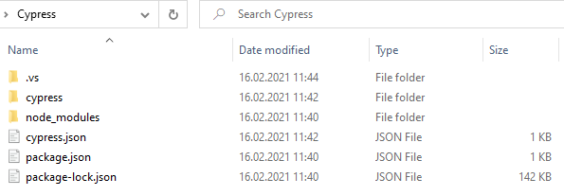

If you installed Cypress with direct download, navigate to the extracted folder and double click on Cypress.exe to launch the application.

1. NPM is short for *Node Package Manager*. It allows you to install JavaScript applications and libraries, like Cypress.
2. Node, or Node.js, allows you to execute JavaScript code on your machine, outside of a browser.